Regular Hexagonal Pyramid
# Source: AI Source: Provided by: [Data Path: Persons Table -> ID Column: 1, Name_En Column: Motasem Essam] -> From: [ChatGPT] on [7/25/2026]
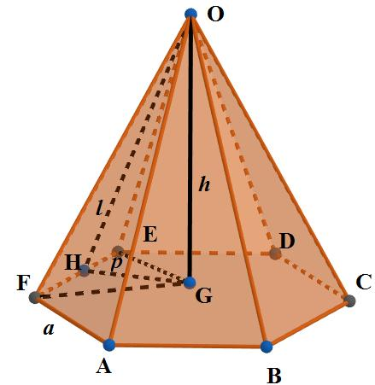
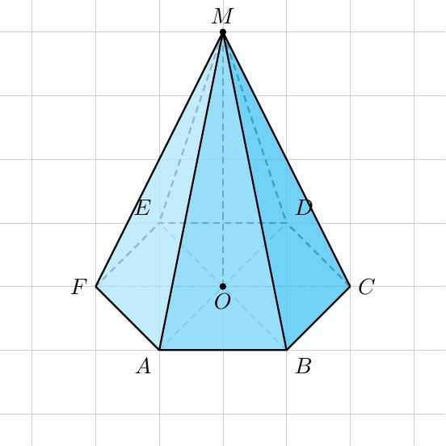
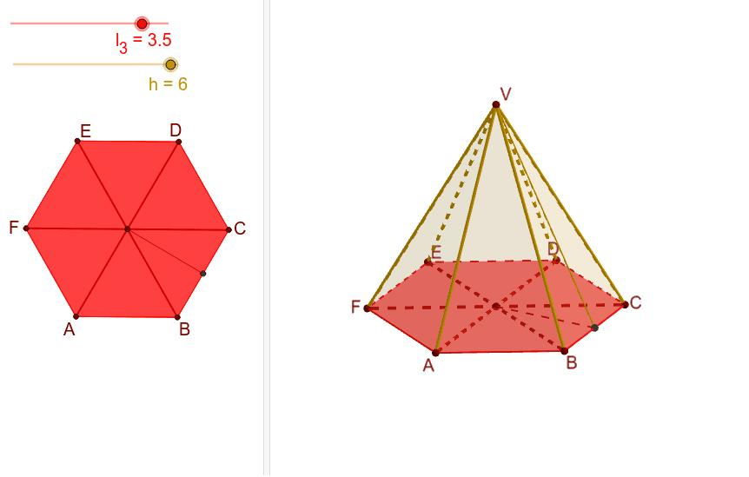

Definition
# Source: AI Source: Provided by: [Data Path: Persons Table -> ID Column: 1, Name_En Column: Motasem Essam] -> From: [ChatGPT] on [7/25/2026]
A regular hexagonal pyramid is a three-dimensional geometric solid with a regular hexagonal base and six congruent isosceles triangular lateral faces that meet at a single point called the apex. Under the standard definition, the apex lies directly above the center of the base, and the pyramid's perpendicular height meets the base at that center.
A regular hexagon has six equal sides and six equal interior angles of ${120}^{∘}$. Because the apex is above the center, the six lateral edges have equal lengths, and the pyramid has rotational symmetry of order six.

Simple Definition
# Source: AI Source: Provided by: [Data Path: Persons Table -> ID Column: 1, Name_En Column: Motasem Essam] -> From: [ChatGPT] on [7/25/2026]
A regular hexagonal pyramid is a pyramid with a six-sided, equal-sided base and six matching triangular side faces, with its apex directly above the center of the base.

Key Characteristics
# Source: AI Source: Provided by: [Data Path: Persons Table -> ID Column: 1, Name_En Column: Motasem Essam] -> From: [ChatGPT] on [7/25/2026]
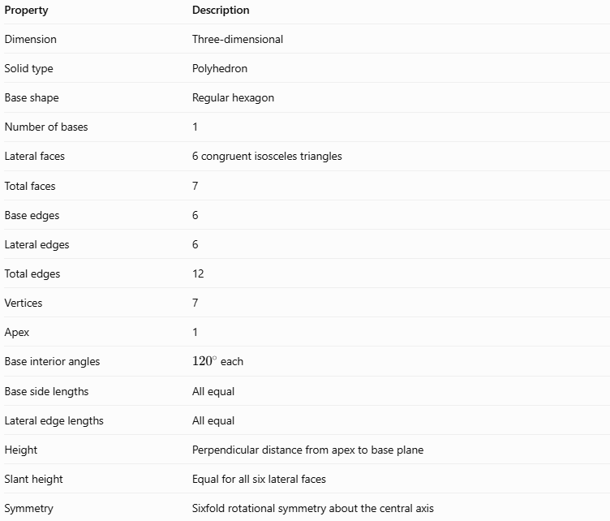
Property | Description
Dimension | Three-dimensional
Solid type | Polyhedron
Base shape | Regular hexagon
Number of bases | 1
Lateral faces | 6 congruent isosceles triangles
Total faces | 7
Base edges | 6
Lateral edges | 6
Total edges | 12
Vertices | 7
Apex | 1
Base interior angles | ${120}^{∘}$ each
Base side lengths | All equal
Lateral edge lengths | All equal
Height | Perpendicular distance from apex to base plane
Slant height | Equal for all six lateral faces
Symmetry | Sixfold rotational symmetry about the central axis

Geometric Representation
# Source: AI Source: Provided by: [Data Path: Persons Table -> ID Column: 1, Name_En Column: Motasem Essam] -> From: [ChatGPT] on [7/25/2026]
The main components are:
- Regular hexagonal base: A six-sided polygon with equal sides and equal interior angles.
- Apex: The point where all six lateral triangular faces meet.
- Base edges: The six equal sides of the hexagon.
- Lateral edges: The six equal segments joining the apex to the base vertices.
- Lateral faces: Six congruent isosceles triangles.
- Height ($h$): The perpendicular distance from the apex to the base plane.
- Base apothem ($r$): The distance from the center of the hexagon to the midpoint of a base edge.
- Slant height ($l$): The altitude of a lateral triangular face, measured from the apex to the midpoint of a base edge.

Mathematical Representations and Formulas
# Source: AI Source: Provided by: [Data Path: Persons Table -> ID Column: 1, Name_En Column: Motasem Essam] -> From: [ChatGPT] on [7/25/2026]
Let:
- $a$ = side length of the hexagonal base
- $h$ = perpendicular height
- $r$ = base apothem
- $l$ = slant height
- $p$ = base perimeter
- $B$ = base area
- $A_{L}$ = lateral surface area
- $A_{T}$ = total surface area
- $V$ = volume

A. Base perimeter
# Source: AI Source: Provided by: [Data Path: Persons Table -> ID Column: 1, Name_En Column: Motasem Essam] -> From: [ChatGPT] on [7/25/2026]
A regular hexagon has six equal sides.
$$\boxed{p=6a}$$

B. Base apothem
# Source: AI Source: Provided by: [Data Path: Persons Table -> ID Column: 1, Name_En Column: Motasem Essam] -> From: [ChatGPT] on [7/25/2026]
The base apothem of a regular hexagon is:
$$\boxed{r=\frac{\sqrt{3}}{2}a}$$

C. Base area
# Source: AI Source: Provided by: [Data Path: Persons Table -> ID Column: 1, Name_En Column: Motasem Essam] -> From: [ChatGPT] on [7/25/2026]
The base area equals half the perimeter multiplied by the apothem.
$$B=\frac{1}{2}pr$$
Substituting $p=6a$ and $r=\frac{\sqrt{3}}{2}a$:
$$\boxed{B=\frac{3\sqrt{3}}{2}a^{2}}$$

D. Slant height
# Source: AI Source: Provided by: [Data Path: Persons Table -> ID Column: 1, Name_En Column: Motasem Essam] -> From: [ChatGPT] on [7/25/2026]
The perpendicular height, base apothem, and slant height form a right triangle.
$$l^{2}=h^{2}+r^{2}$$
Therefore,
$$\boxed{l=\sqrt{h^{2}+r^{2}}}$$
Or, using the side length:
$$\boxed{l=\sqrt{h^{2}+{\frac{3}{4}a}^{2}}}$$

E. Lateral surface area
# Source: AI Source: Provided by: [Data Path: Persons Table -> ID Column: 1, Name_En Column: Motasem Essam] -> From: [ChatGPT] on [7/25/2026]
The pyramid has six congruent triangular lateral faces.
$$A_{L}=\frac{1}{2}pl$$
Thus,
$$\boxed{A_{L}=3al}$$

F. Total surface area
# Source: AI Source: Provided by: [Data Path: Persons Table -> ID Column: 1, Name_En Column: Motasem Essam] -> From: [ChatGPT] on [7/25/2026]
The total surface area includes the hexagonal base and all six triangular faces.
$$A_{T}=B+A_{L}$$
Therefore,
$$\boxed{A_{T}=\frac{3\sqrt{3}}{2}a^{2}+3al}$$

G. Volume
# Source: AI Source: Provided by: [Data Path: Persons Table -> ID Column: 1, Name_En Column: Motasem Essam] -> From: [ChatGPT] on [7/25/2026]
The volume of any pyramid is one-third of the product of its base area and perpendicular height.
$$V=\frac{1}{3}Bh$$
For a regular hexagonal pyramid:
$$\boxed{V=\frac{\sqrt{3}}{2}a^{2}h}$$

H. Lateral edge length
# Source: AI Source: Provided by: [Data Path: Persons Table -> ID Column: 1, Name_En Column: Motasem Essam] -> From: [ChatGPT] on [7/25/2026]
The lateral edge $e$ joins the apex to a vertex of the hexagonal base. For a regular hexagon, the distance from the center to a vertex equals $a$.
$$e=\sqrt{h^{2}+a^{2}}$$
Hence,
$$\boxed{e=\sqrt{h^{2}+a^{2}}}$$
Remember that the lateral edge $e$ and slant height $l$ are different measurements.

Worked Examples
# Source: AI Source: Provided by: [Data Path: Persons Table -> ID Column: 1, Name_En Column: Motasem Essam] -> From: [ChatGPT] on [7/25/2026]
Example 1: Counting faces, edges, and vertices
A regular hexagonal pyramid has a base with six sides.
- Faces: $6+1=7$
- Edges: $2\left(6\right)=12$
- Vertices: $6+1=7$
Check Euler’s formula:
$$V_{e}-E+F=7-12+7=2$$
The result confirms the relationship for this convex polyhedron.
Example 2: Calculating the base area
Suppose the side length of a regular hexagonal pyramid's base is $4\text{ cm}$.
Using the base-area formula:
$$B=\frac{3\sqrt{3}}{2}a^{2}$$
Substitute $a=4$:
$$B=\frac{3\sqrt{3}}{2}{\left(4\right)}^{2}$$
$$B=24\sqrt{3}$$
$$\boxed{B≈41.57{\text{ cm}}^{2}}$$
Example 3: Calculating the volume
Suppose a regular hexagonal pyramid has a base side length of $4\text{ cm}$ and a perpendicular height of $9\text{ cm}$.
First, calculate the base area:
$$B=24\sqrt{3}{\text{ cm}}^{2}$$
Then calculate the volume:
$$V=\frac{1}{3}Bh$$
$$V=\frac{1}{3}\left(24\sqrt{3}\right)\left(9\right)$$
$$\boxed{V=72\sqrt{3}≈124.71{\text{ cm}}^{3}}$$
Example 4: Calculating the surface area
Suppose the base side length is \(6\text{ cm}\) and the perpendicular height is $8\text{ cm}$.
Step 1 — Calculate the base area
$$B=\frac{3\sqrt{3}}{2}{\left(6\right)}^{2}$$
$$B=54\sqrt{3}≈93.53{\text{ cm}}^{2}$$
Step 2 — Calculate the slant height
$$r=\frac{\sqrt{3}}{2}\left(6\right)=3\sqrt{3}$$
$$l=\sqrt{8^{2}+{\left(3\sqrt{3}\right)}^{2}}$$
$$l=\sqrt{91}≈9.54\text{ cm}$$
Step 3 — Calculate the lateral surface area
$$A_{L}=\frac{1}{2}\left(36\right)\sqrt{91}$$
$$A_{L}=18\sqrt{91}≈171.66{\text{ cm}}^{2}$$
Step 4 — Calculate the total surface area
$$A_{T}=54\sqrt{3}+18\sqrt{91}$$
$$\boxed{A_{T}≈265.19{\text{ cm}}^{2}}$$

Comparison with Related Concepts
# Source: AI Source: Provided by: [Data Path: Persons Table -> ID Column: 1, Name_En Column: Motasem Essam] -> From: [ChatGPT] on [7/25/2026]
Regular Hexagonal Pyramid
Has a regular hexagonal base, a centered apex, and six congruent isosceles triangular faces.
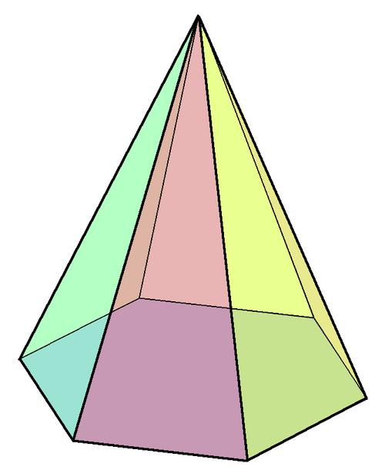
Irregular Hexagonal Pyramid
Has an irregular six-sided base. Its base edges and lateral faces are not necessarily equal.
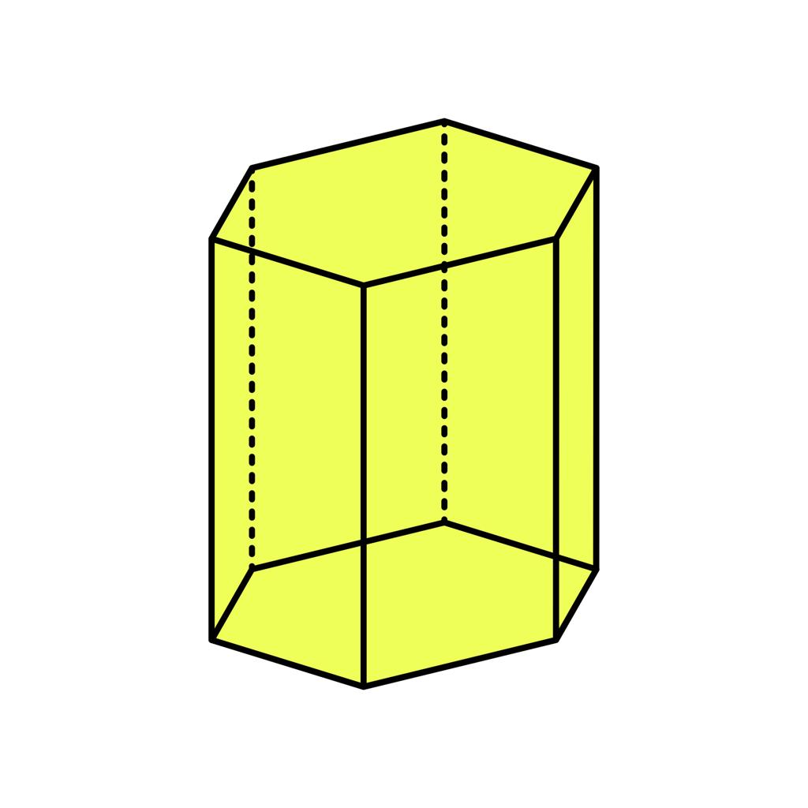
Hexagonal Prism
Has two parallel, congruent hexagonal bases connected by six lateral faces, rather than one base and a single apex.
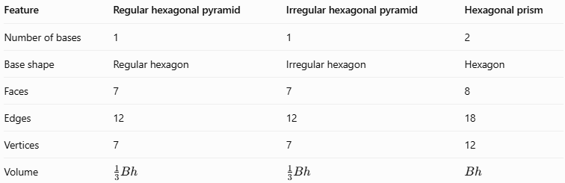
Feature | Regular hexagonal pyramid | Irregular hexagonal pyramid | Hexagonal prism
Number of bases | 1 | 1 | 2
Base shape | Regular hexagon | Irregular hexagon | Hexagon
Faces | 7 | 7 | 8
Edges | 12 | 12 | 18
Vertices | 7 | 7 | 12
Volume | $$\frac{1}{3}Bh$$ | $$\frac{1}{3}Bh$$ | $$Bh$$

Applications
# Source: AI Source: Provided by: [Data Path: Persons Table -> ID Column: 1, Name_En Column: Motasem Essam] -> From: [ChatGPT] on [7/25/2026]
- Architecture: Pyramid-shaped roof structures and decorative roof features.
- Packaging: Hexagonal gift boxes or display objects with tapered tops.
- Engineering and design: Modeling tapered components with sixfold symmetry.
- Computer graphics: Building regular polygon-based 3D models.
- Mathematics education: Demonstrating how a regular polygon forms the base of a pyramid and how the base dimensions affect volume and surface area.

Key Points
# Source: AI Source: Provided by: [Data Path: Persons Table -> ID Column: 1, Name_En Column: Motasem Essam] -> From: [ChatGPT] on [7/25/2026]
- A regular hexagonal pyramid has 7 faces, 12 edges, and 7 vertices.
- Its base is a regular hexagon with six equal sides and six ${120}^{∘}$ interior angles.
- Its six lateral faces are congruent isosceles triangles.
- Its apex lies directly above the center of the base.
- Its volume is $V=\frac{1}{3}Bh$.
- Its lateral surface area is $A_{L}=\frac{1}{2}pl$.
- Its slant height and lateral edge length are different.
- The term regular describes both the regular base and the symmetric pyramid arrangement.

Conclusion
# Source: AI Source: Provided by: [Data Path: Persons Table -> ID Column: 1, Name_En Column: Motasem Essam] -> From: [ChatGPT] on [7/25/2026]
A regular hexagonal pyramid is a polyhedron formed by a regular hexagonal base and six congruent triangular lateral faces meeting at a centered apex. Its symmetry makes the calculations of perimeter, base area, slant height, lateral surface area, total surface area, and volume straightforward. Understanding its structure also helps distinguish it from an irregular hexagonal pyramid and a hexagonal prism.

